**Edinburgh Area**

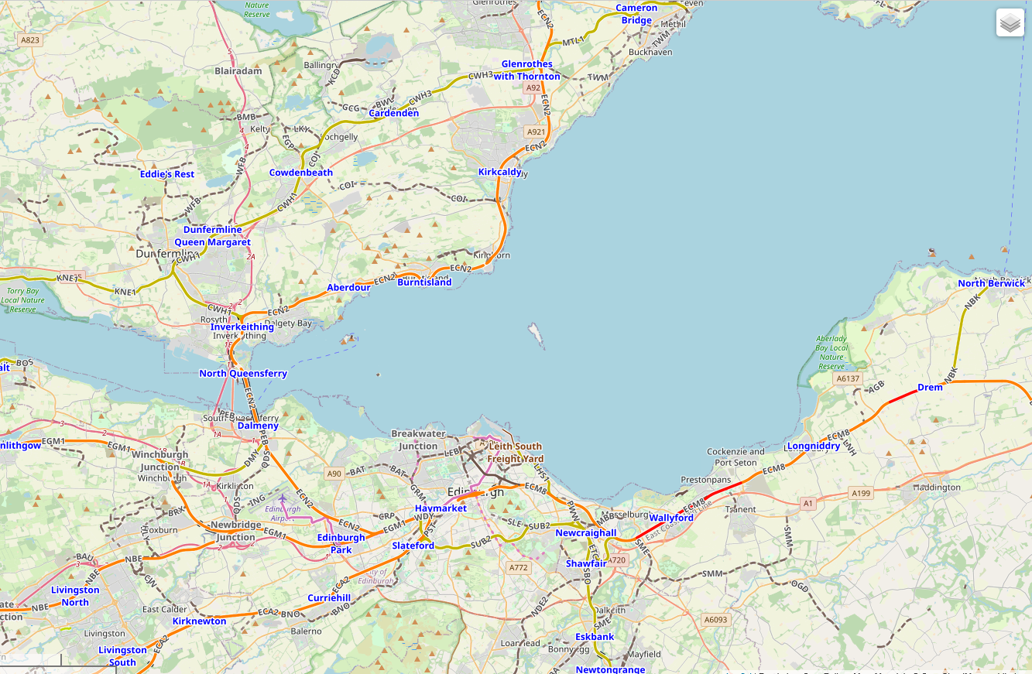

This project covers quite a wide area surrounding Edinburgh, most of which is shown on the map above.

Extracted from OpenRailwayMap

*[extract permitted under the Creative Commons Attribution-ShareAlike 2.0 license (CC BY-SA 2.0)]*

**Edinburgh Waverley Station**

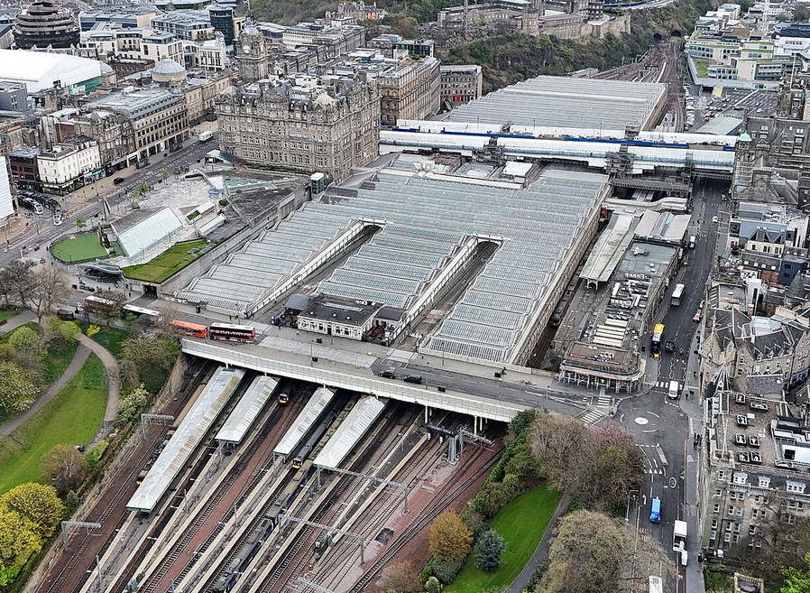

Photograph by 瑞丽江的河水

*[copied under the Creative Commons Attribution-Share Alike 4.0 International licence]*

**Operational notes:**

Close to and at Edinburgh Waverley traffic is intense most of the time, and great care and attention is needed in signalling trains in and out of the station in their correct order.

Ensure that the designated platforms at Edinburgh are used or severe delays are likely as a result of having to clear obstructions.

Always check Edinburgh platforms early for arriving trains and for trains from the west be prepared to cross tracks before Haymarket or at Princes Street Gardens. On the eastern side of Edinburgh Waverley there are only two tracks so they often become very congested. Check timings to ensure that trains arrive on time as closely as possible and in the correct order.

Very often two or even three trains are required to occupy the same platform at Edinburgh so it is necessary to check their arrival times to make sure they arrive in the correct order. Sometimes it will be necessary to hold an earlier train back to allow a later train to arrive before it.

When trains have to wait at Princes Street Gardens try to use the top or bottom tracks so they can wait between signals and others can bypass them.

After trains change tracks at Princes St Gardens or near Haymarket change the points back to horizontal as soon as possible or later trains will be misrouted and delayed.

Be prepared to use a lot of call-ons at Haymarket to avoid delays.

Empty Coaching Stock (ECS - headcodes generally begin with 5) normally have very generous time allowances to allow other trains (even stopping trains) to precede them without their being delayed.

Services to Tweedbank from Edinburgh have generous time allowance before Brunstane to allow waiting times for other trains to cross their path.

Check arrival times at Glenrothes with Thornton and ensure that trains are scheduled in the correct order.

Watch timings for trains approaching Newbridge Jn towards Edinburgh and ensure that trains that arrive at Haymarket and Edinburgh first cross the junction first.

Ensure that trains to and from Tweedbank are correctly routed to pass each other at the three passing places - Shawfair, Gorebridge Loops and Stow.

When trains are to enter Craigentinny Depot check first the times of trains leaving the depot and hold entering trains back if required.

Note that there is plenty of scope for extending automatic signal routes for outlying areas, especially across two-track crossovers and passing loops, but be ready to cancel short sections of these routes when a loop is to be used. Note also that there are no services to Lanark, Alloa or Stirling in this timetable.

**********************************